Science for Citizens 11 Name: _________________________
Why do people become criminals?
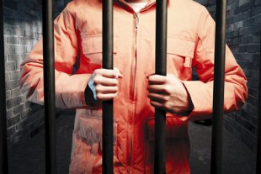
WHY are we doing this?!
Research is a very important part of science! Scientists must research to gain knowledge. By researching we can learn to make our own ideas from the thoughts of others. Also, researching is not enough by itself! We must be able to write down and communicate our ideas with others!

In a powerpoint presentation or essay, complete the following:

Part One:
- Why do people become criminals? Include at least two researched theories on why people commit crime. This is generally speaking - not a specific criminal.

Some good links to check out:
https://owlcation.com/social-sciences/Psychology-of-Crime-Why-do-people-become-criminals

https://onlinedegrees.kent.edu/sociology/criminal-justice/community/criminal-behavior-theories

This section should be about 5-6 slides or 1-2 pages double spaced.

Part Two:
- Choose any famous criminal/crime that interests you. Describe the crime and apply the knowledge that you have learned from part one and explain why you think this person became a criminal and committed this crime.

This section should be about 5-6 slides or 1-2 pages double spaced.
Remember, no copying and pasting. Everything needs to be in your own words.

Cite all of your resources.
MARKING RUBRIC

 | Excellent (4) | Good (3) | Fair (2) | Needs Work (1)
Content: Completion | All parts have been thoroughly completed. | All parts have been completed but missing some information. | Some parts have been completed, lots of missing information. | Hardly any of the project has been completed.
Content: Accuracy | Content is completely accurate. | Most content is accurate. | Some content is accurate. | Most of the content is inaccurate.
Organization/Neatness | Project is very organized and neat. | Project is organized and neat. | Project is messy and hard to follow. | Project has no organization and is very messy.
Mechanics | There are little to no errors in sentence structure, grammar, spelling, etc... | There are a few errors in sentence structure, grammar, spelling, etc... | There are many errors in sentence structure, grammar, spelling, etc.. | There has been no attempt to have good sentence structure, grammar or spelling.
Bibliography | Bibliography is present and complete | Bibliography is present but missing some information. | Bibliography is present but is missing plenty of information. | Bibliography is not present

